Cape Economic Performance and Prospect Bulletin – March 2026
Highlights
- Price pressures expected to sustain moderation in 2026 prompting easing monetary policy.
- Nigeria’s output growth in 2026 is expected to remain positive as economy stabilises and consolidates reforms.

Global Economic Update
The global economy entered the first quarter of 2026 with moderate but steady momentum. By February, economic activity showed signs of stabilizing, though performance varied significantly across regions. The United States remained the primary driver of growth among Advanced Economies (AEs), supported by a resilient labour market and a surge in AI‑driven capital expenditures that continued to stimulate corporate investment and productivity gains. In contrast, the Eurozone struggled to regain momentum, constrained by persistently high energy costs, weak industrial output, and underlying structural rigidities that limited the pace of recovery.
Among Emerging Market and Developing Economies (EMDEs), growth generally outpaced that of advanced economies. This resilience was underpinned by solid domestic demand, improving labour markets, and relatively stable financial inflows. India and several Southeast Asian economies sustained strong growth trajectories, driven by robust investment spending and steady private consumption. However, these economies also began to feel the growing impact of global “trade fragmentation,” as supply chains continued to realign along geopolitical rather than purely cost‑efficiency considerations.
China registered a modest improvement in economic momentum, reflecting the delayed but emerging effects of its late‑2025 stimulus measures. These policies, introduced to counteract the prolonged downturn in the property sector, helped stabilize investment activity and bolster consumer and business confidence. While challenges in the real estate market persisted, the overall economic outlook showed early signs of gradual strengthening.
Inflation trends became increasingly synchronised across regions during this period, reflecting the gradual unwinding of global price shocks that had accumulated over the previous years. Across several advanced economies, including the United States, the United Kingdom, and the euro area, disinflationary progress continued, supported by easing supply-chain pressures, slowing goods prices, and more stable energy markets. Headline and core inflation drifted closer to medium-term targets, although not without volatility. Persistent tail risks remain, particularly from elevated geopolitical uncertainty, potential supply disruptions in global energy markets, and pockets of tightness in labour markets that continue to exert upward pressure on wages and services prices.
A broadly similar trend emerged in many EMDEs, albeit with greater variation. Notably, a number of countries in Sub-Saharan Africa experienced a marked moderation in inflation, retreating from the exceptionally high peaks reached in the aftermath of global supply shocks, exchange rate depreciations, and food price spikes. Improved agricultural output in some economies, stabilising import costs, and targeted monetary tightening have contributed to this easing.
Nevertheless, headline inflation remained elevated and, in many cases, uncomfortably high, across several EMDEs. In several countries, inflation persisted in double-digit territory, underpinned by structural constraints such as chronic supply bottlenecks, weak transport and logistics networks, and persistent foreign-exchange fragilities. Volatile capital flows and heightened external financing pressures continued to transmit global cost-push shocks into domestic prices. Additionally, the reliance of many EMDEs on imported food, refined petroleum products, and intermediate goods left them highly vulnerable to fluctuations in global commodity prices and shifts in geopolitical risk. These structural vulnerabilities have limited the pace of disinflation and complicated monetary policy responses.
Overall, while inflation dynamics have broadly improved worldwide, the process remains uneven and susceptible to renewed shocks. The convergence in inflation trends masks deeper divergences in economic resilience and policy space, underscoring the fragility of the global disinflation path amid rising geopolitical uncertainty.
Figure 1: Year-on-Year Inflation in Selected Economies (December 2025 – January 2026) in percent

Source: Various National Statistics Offices
Central banks in advanced economies maintained a cautious shift toward monetary easing as economic momentum softened, yet they remained alert to lingering inflationary pressures. The re-emergence of price stickiness in selected sectors, particularly services, shelter, and energy adjacent industries, reinforced a preference for gradualism and strong data dependence. As a result, policymakers adopted a measured approach, signalling that any rate cuts would proceed slowly and remain conditional on continued progress in disinflation.
These policy decisions were closely scrutinized by global markets not only for their implications on inflation dynamics and labour market conditions, but also for what they revealed about institutional independence. In the United States, the Federal Reserve faced heightened political attention ahead of the electoral cycle, prompting investors and analysts to monitor its forward guidance for signs of pressure or shifts in its autonomy. Similar concerns were echoed in parts of Europe and the United Kingdom, where central banks were attempting to balance credibility in achieving inflation targets with the need to support weakening domestic demand.
A comparable trend unfolded across emerging market and frontier economies, where monetary policy paths began converging, albeit cautiously toward a more accommodative stance. Many of these central banks, having tightened aggressively earlier to contain inflation and stabilize exchange rates, now saw room to begin easing as price pressures moderated. Nonetheless, the pace of adjustment remained uneven. Concerns over volatile capital flows, currency depreciation risks, and limited policy buffers compelled several EMDEs to adopt a slower and more risk averse approach. In economies with persistent external vulnerabilities or elevated sovereign borrowing costs, policymakers exercised additional restraint to avoid reigniting inflation or triggering financial stability pressures.
In February 2026, the S&P 500 declined by approximately 0.9 per cent, while the Dow Jones Industrial Average rose about 0.2 per cent. Market breadth, however, was uneven. Mid- and small-capitalisation equities outperformed large-cap benchmarks, with the S&P MidCap 400 posting a gain of roughly 3.1 per cent.
This divergence highlighted a significant rotation away from the mega-cap technology names that had previously dominated the market. While the tech-heavy Nasdaq struggled under the weight of an "AI expectation reset," smaller companies benefited from a cooling inflation outlook and a subsequent drop in Treasury yields, allowing the broader market to find support outside of the traditional growth giants.
Geopolitical developments continued to complicate an already fragile global macroeconomic environment. Persistent trade disputes weighed heavily on international commerce, dampening business sentiment and prompting firms to reassess the resilience of their production networks. These frictions accelerated the ongoing reorganisation of global supply chains, as countries and multinational corporations increasingly prioritized geopolitical alignment, strategic security, and diversification over traditional cost efficiency considerations.
In Europe, tentative signals from Kyiv regarding the possibility of renewed peace talks with Moscow offered guarded optimism but were accompanied by significant ambiguity and limited prospects for meaningful de-escalation. The ongoing conflict continued to inject volatility into energy markets, elevate risk premia, and discourage long term cross border investment, particularly in energy intensive and manufacturing driven sectors. Structural uncertainty surrounding the trajectory of the war also complicated fiscal planning and external financing conditions across the region.
The coordinated US–Israel military action in Iran on February 28, 2026 significantly intensified geopolitical tensions in the Middle East, further undermining prospects for regional stability and increasing global economic uncertainty. The escalation heightened concerns over the security of key maritime routes, energy infrastructure, and cross-border trade flows, reinforcing the growing importance of geopolitical risk as a source of global economic volatility.
Consequently, conditions in Middle East have since remained fragile, particularly as retaliatory attacks have affected US allies. While the drivers of instability vary across conflict zones, the cumulative effect has been a broad increase in global geopolitical risk premia. Heightened concerns about potential disruptions to energy supply chains, maritime security, and international trade have made investors more cautious. As a result, sustained uncertainty has weighed on investor sentiment, increased hedging costs, and complicated macroeconomic policy management across both advanced and emerging economies.
Within commodity markets, crude oil prices rose steadily throughout February 2026, supported initially by improving cyclical sentiment and later by mounting geopolitical tensions. Brent crude traded near multi month highs, with spot prices fluctuating around US$70.89–US$71.87 per barrel by late February. West Texas Intermediate (WTI) followed a similar pattern, hovering around US$66.66–US$70 per barrel during the same period. These movements reflected a combination of steady global demand, disciplined OPEC+ output, and the influence of a strengthening risk premium.
Much of the price support during the month was driven by improved cyclical sentiment, including steady consumption in major markets, declining inventories in some regions, and expectations of gradual monetary easing across advanced economies. However, the broader outlook for oil prices still appeared tilted to the downside. Structural fragilities in the global financial system, persistent protectionist policies affecting trade flows, and the potential for renewed supply growth, particularly from U.S. shale producers responding to higher price incentives, could intensify downward pressure should global demand weaken further.
However, the war emerging in the Middle East has altered the risk balance considerably. The February 28, 2026 US–Israel military action in Iran and subsequent regional escalations significantly raised geopolitical uncertainty, reinforcing an upward risk premium in global energy prices. This heightened risk environment, combined with concerns about disruptions to supply routes; including potential instability around the Strait of Hormuz, has the potential to keep crude benchmarks elevated, offsetting some of the downward pressures that would otherwise dominate the medium term price outlook.
At the same time, geopolitical developments continue to pose clear upside risks. Elevated tensions and escalating conflict across the Middle East leave oil markets vulnerable to sudden supply disruptions, shipping route blockages, and heightened risk premia. Further escalation could impair critical maritime corridors, including the Strait of Hormuz, intensify insurance and shipping costs, and generate sharp, geopolitically induced price spikes. This backdrop highlights the persistent exposure of oil markets to geopolitical and macro financial shocks, with major implications for inflation dynamics in energy importing economies and fiscal positions in oil exporting countries.
Gold prices have risen sharply, climbing to approximately US$5,278 per ounce by late February 2026, supported by heightened risk aversion, sustained central bank diversification of reserves, and a broad-based softening of the U.S. dollar. This shift signals that global risk is increasingly transmitted through financial markets, with important consequences for capital flows, exchange rate movements, and macroeconomic stability, especially in emerging and developing economies that remain vulnerable to external financial shocks.
The cryptocurrency market in February 2026 experienced heightened volatility and continued corrective pressures, reflecting deteriorating risk sentiment, and shifting macro financial expectations. Bitcoin recorded a substantial decline from earlier highs, falling from about US$91,000 to roughly US$78,000 year to date, while mid-month spot data placed it nearer US$70,731 as of February 15. Ethereum also faced sustained downward pressure, trading around US$2,090 after deeper percentage losses relative to Bitcoin.
Total cryptocurrency market capitalisation fell sharply to around US$2.57 trillion, with approximately US$410 billion erased since early January amid risk off positioning, a stronger U.S. dollar, and significant spot ETF outflows that weakened institutional demand. Large cap assets accounted for the majority of market value, with Bitcoin dominance near 58.65 per cent, while smaller segments exhibited mixed performance as liquidity thinned and speculative activity softened. Stable coins remained broadly stable, maintaining their critical role in exchange liquidity and on chain settlement, with leading tokens such as USDT and USDC holding their pegs and supporting high transaction turnover.
Regulatory and institutional developments progressed further in February 2026, with policymakers advancing work on cross border regulatory coordination, clearer stable coin frameworks, and enhanced market integrity provisions in response to rising volatility and growing institutional participation. Overall, the month was characterised by renewed financial market turbulence, heightened geopolitical risk transmission, and an increasingly cautious investor stance across both traditional and digital asset markets.

Global Economic Outlook
The global economy entered 2026 on a comparatively steadier footing than the turbulence that characterised the opening months of 2025. Financial markets and policymakers have increasingly absorbed the implications of persistent trade disruptions and geopolitical frictions, helping to reduce short term uncertainty. However, the recent escalation in the Middle East is expected to weigh on confidence, increase risk premia, and introduce fresh downside risks to global trade and energy markets, particularly if tensions disrupt critical shipping routes or trigger sustained volatility in commodity markets.
In the United States, economic momentum is projected to remain solid, with GDP forecast to grow by 2.8 per cent in 2026, supported by tax incentives, easing financial conditions, resilient consumer spending, and robust business investment. The euro area is expected to experience a modest improvement, with GDP growth around 1.3%, underpinned by fiscal support and gradual recovery in private consumption. Among emerging economies, China and India are expected to remain key growth drivers, supported by strong domestic demand, targeted policy support, and investment in technology and manufacturing ecosystems.
Monetary policy paths are likely to converge gradually but remain broadly cautious. Central banks in advanced economies are expected to proceed carefully with rate cuts as inflation decelerates but remains sensitive to geopolitical shocks and supply side uncertainties. This reflects the need to balance price stability with growing concerns over softer labour markets and slowing demand. In a similar vein, several economies in Latin America and Sub Saharan Africa may begin cautiously easing monetary policy as inflation moderates, though exchange rate fragilities and external financing conditions will necessitate prudence.
Global trade is expected to expand modestly, although at a slower pace than historical averages due to ongoing fragmentation, realignment of supply chains, and rising geopolitical barriers.
Commodity markets are likely to remain volatile, shaped by cyclical factors, shifting demand expectations, and geopolitical tensions. In energy markets, higher than expected geopolitical uncertainty, particularly in the Middle East, is likely to keep a risk premium embedded in oil prices, even as structural forces (such as rising non-OPEC supply) exert downward pressure.
As a result, energy prices are likely to remain elevated and volatile, with potential for sudden spikes if supply disruptions materialise. Demand for industrial metals may strengthen moderately, driven by infrastructure spending and investments in clean energy technologies. Agricultural commodity prices are expected to stabilise, barring climate related shocks or renewed trade restrictions.
In an environment shaped by heightened geopolitical risk, policy uncertainty, and structural economic transitions, effective policy coordination will become increasingly important. Policymakers will need to restore fiscal buffers, preserve price and financial stability, and implement structural reforms to bolster confidence and resilience across global value chains, ensuring that economies remain adaptable in the face of overlapping shocks.

Nigeria’s Output Growth
Nigeria’s output growth strengthened further in the fourth quarter of 2025, as real Gross Domestic Product (GDP) expanded by 4.07 percent year-on-year, representing an improvement from the 3.76 percent recorded in the corresponding quarter of 2024. The growth signals improving macroeconomic conditions and a gradual strengthening of economic fundamentals.

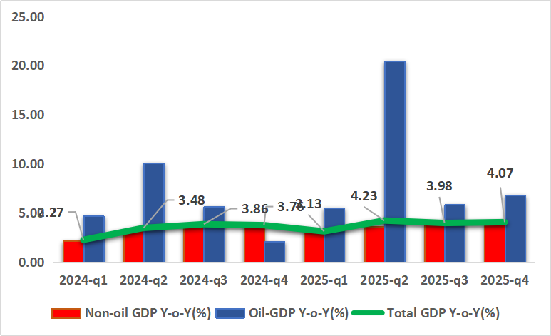
Figure 2: Real GDP Growth Rate in Nigeria (Q12024 – Q42025) in percent

Source: National Bureau of Statistics (NBS)

In nominal terms, quarterly economic output rose to ₦122.81 trillion, compared with ₦104.48 trillion in the same period of 2024, reflecting a 17.55 percent increase year-on-year. On an annual basis, Nigeria’s economy grew by 3.87 percent in 2025, higher than the 3.38 per cent recorded in 2024, while the overall size of the economy increased to ₦441.5 trillion, up from ₦372.8 trillion in the previous year. The improved growth profile reflects the combined influence of ongoing macroeconomic adjustments, policy reforms, and gradually strengthening investor confidence.

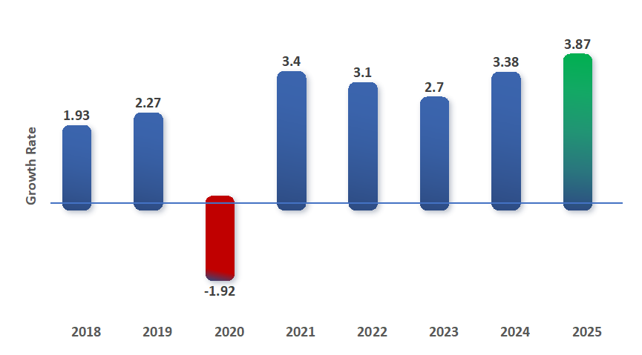
Figure 3: Annual Real GDP Growth Rate in Nigeria (2018 – 2025) in percent

Source: National Bureau of Statistics (NBS)

Growth during the quarter continued to be anchored by the non-oil sector, which expanded by 3.99 per cent in real terms, representing a marginal improvement over the 3.80 per cent recorded in the corresponding quarter of 2024 and the 3.91 per cent growth posted in the preceding quarter. The sector remained the dominant contributor to economic activity, accounting for 97.13 per cent of total real GDP, compared with 97.20 per cent in Q4 2024 and 96.56 per cent in Q3 2025. Output expansion within the non-oil economy was supported by increased activities in several key segments, including crop production, telecommunications, real estate, trade, financial services, construction, transportation, and food manufacturing, highlighting the continued importance of diversified non-oil economic activity in sustaining overall growth.

Figure 3: Oil and Non-Oil Contribution to GDP
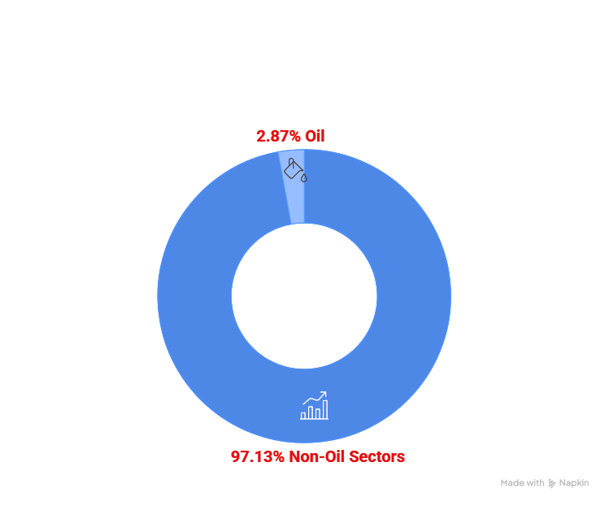

Source: National Bureau of Statistics (NBS)

Sectoral developments indicate that all three broad sectors of the economy recorded positive growth during the period under review. The agriculture sector, which accounted for 25.67 percent of GDP, expanded by 4.00 per cent, representing a notable improvement relative to the 2.54 per cent recorded in the same quarter of 2024, supported by better farming conditions, improved security in key food-producing areas, and increased access to agricultural inputs. The industrial sector, accounting for 18.41 percent of GDP, recorded growth of 3.88 per cent, up from 2.49 per cent in the corresponding quarter of the previous year, reflecting improved production conditions in manufacturing and energy-related activities as well as better access to foreign exchange for industrial inputs. The services sector remained the largest component of the economy, growing by 4.15 per cent and accounting for 55.92 per cent of total GDP, slightly higher than its share of 55.87 per cent recorded in Q4 2024. The expansion in services continued to be driven by strong activity in financial services, telecommunications, trade, and other technology-enabled segments.

Figure 4: Sectoral Contributions to Real GDP
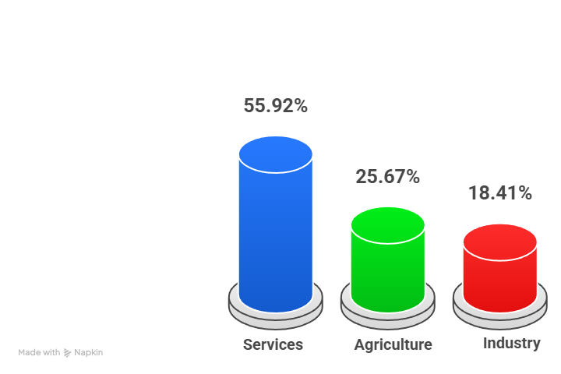

Source: National Bureau of Statistics (NBS)

Overall, about thirty subsectors recorded growth rates above 3.0 per cent, indicating that economic expansion during the quarter was relatively broad-based across different segments of the economy. The top 5 performing sectors are as presented below.

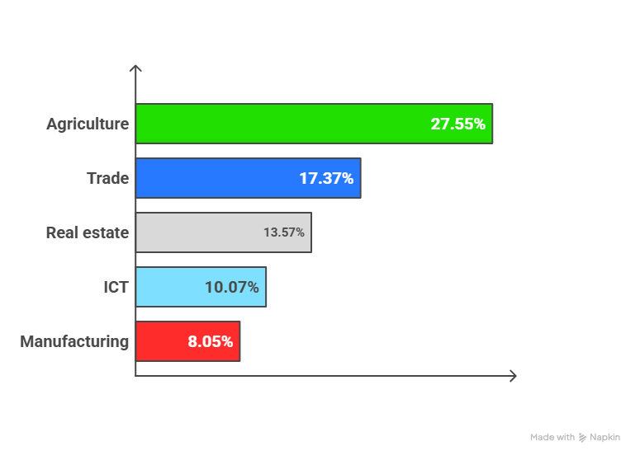
Figure 5: Top 5 Drivers of Q4 2025 Real GDP

Source: National Bureau of Statistics (NBS)

The oil sector also recorded improved performance, with real output increasing by 6.79 per cent year-on-year in Q4 2025, compared with 2.08 per cent in the corresponding quarter of 2024 and 5.84 per cent in the preceding quarter. The improvement was associated with moderately higher crude oil production levels, as average daily output increased to 1.58 million barrels per day, compared with 1.54 million barrels per day recorded in Q4 2024, although it remained slightly below the 1.64 million barrels per day recorded in Q3 2025. Despite the stronger growth rate, the oil sector continued to represent a relatively small share of overall economic output, accounting for 2.87 per cent of real GDP, compared with 2.80 per cent in Q4 2024 and 3.44 per cent in the preceding quarter. On an annual basis, the oil sector contributed 3.53 per cent to total GDP in 2025, marginally higher than the 3.38 per cent recorded in 2024, reflecting modest improvements in hydrocarbon production within an increasingly diversified economic structure.

Overall, the fourth-quarter 2026 performance reinforces the resilience of Nigeria’s economic recovery and the increasing diversification of output across sectors, with stronger contributions from agriculture, industry, and services alongside a modest rebound in oil production. The improvement in growth outcomes reflects the gradual impact of macroeconomic reforms, enhanced policy coordination, and improving sectoral activity. Maintaining this momentum will require sustained macroeconomic stability, improvements in energy supply, continued exchange rate stability, and targeted policies aimed at reducing structural bottlenecks in agriculture and industry. Strengthening productivity, deepening investment, and expanding private-sector participation will remain essential for sustaining inclusive and durable economic growth in the medium term.
Looking at Q1 2026, Nigeria’s growth momentum continued to reflect underlying economic resilience, despite prevailing macroeconomic and cost pressures. After the temporary slowdown recorded in January, some high-frequency indicators suggest a rebound in private sector activity in February. The Stanbic IBTC Purchasing Managers’ Index (PMI) increased to 53.2 points in February 2026 from 49.7 points in January, indicating a return to expansion in business conditions, supported largely by stronger customer demand and a recovery in new orders and output. Similarly, the Central Bank of Nigeria’s Composite PMI indicated sustained improvement in aggregate economic activity, rising to 56.4 points in February 2026 from 55.7 points in January. The increase in the headline index reflects continued growth across key sectors of the economy, supported by improvements in production levels, new orders, employment, and inventory accumulation.

Figure 6a: Trend of Nigeria’s PMI (Feb. 2025– Feb. 2026)
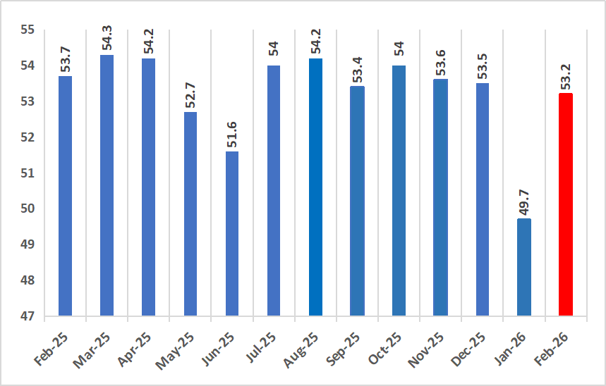
Source: Stanbic-IBC

Figure 6b: Trend of Nigeria’s PMI (Feb. 2025–Feb. 2026)
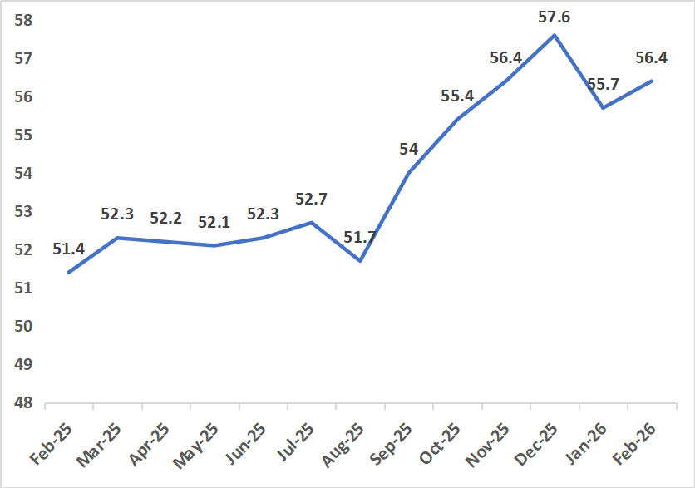

Source: CBN

Sectoral developments suggest that the rebound in February was relatively broad-based, with increased demand encouraging firms to expand output, rebuild inventories, and modestly increase employment levels. At the same time, price pressures moderated somewhat, partly reflecting improved foreign exchange conditions which helped ease the pace of increase in input costs. Overall, the February PMI readings indicate that the slowdown observed in January was largely temporary, with business conditions remaining supportive of output growth in the early months of 2026.

Output Growth Outlook
Nigeria enters 2026 with early signs of macroeconomic stabilisation, following two years of major monetary, fiscal, and exchange rate reforms. GDP growth in 2025 averaged between 3.1% and 4.2%, supported by resilient services activity, modest recovery in the oil sector, and improved foreign exchange liquidity conditions. Looking ahead to 2026, the economy continues to demonstrate a measure of underlying resilience despite sustained macroeconomic pressures, a pattern expected to persist through the year. Real output growth is projected to remain positive, averaging 4.0–5.0 per cent, although the pace of expansion is likely to remain measured. Structural impediments—most notably infrastructure deficiencies, low productivity growth, and constrained access to finance—are expected to limit the speed of recovery.
In addition, the recent outbreak of war in Iran introduces fresh external risks for Nigeria, primarily through heightened oil price volatility, increased global risk aversion, and potential capital outflows. As a small open oil exporting economy with a high degree of exposure to foreign portfolio investment, Nigeria remains vulnerable to shifts in global financial conditions. A prolonged conflict could raise Nigeria’s risk premium, slow inflows into domestic debt and equity markets, increase external borrowing costs, and generate renewed exchange rate pressure, all of which may weigh on private investment and moderate near-term output gains.
Nonetheless, structural rigidities, high logistics costs, insecurity, weak electricity supply, and limited capital spending, could keep output growth below its full potential.
Figure 7: Economic Policy Uncertainty (EPU) index for Nigeria February 2025 – February 2026
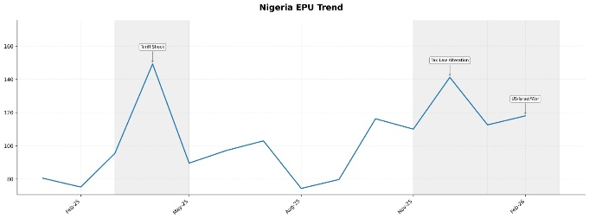
Source: CAPE Economic Research and Consulting, 2026
Nigeria’s Economic Policy Uncertainty (EPU) Index recorded a spike in February 2026, following the outbreak of the war in Iran, as global risk aversion intensified. Because Nigeria is a small, open, oil exporting economy with substantial exposure to foreign portfolio investment (FPI), the conflict triggered heightened sensitivity to external shocks. As flight to safety flows strengthened—redirecting capital toward advanced economy safe haven assets, emerging market risk premia widened, and Nigeria experienced renewed uncertainty around fiscal sustainability, FX management, and oil revenue stability.
As the war prolongs, the EPU spike reflects a meaningful increase in perceived policy risk and macroeconomic ambiguity, driven by concerns over potential disruptions in global oil supply, volatility in FX inflows, and the sustainability of domestic policy reforms.
This upward movement suggests that investors may adopt a more cautious stance, delaying long term commitments, shortening portfolio duration, and pricing in higher compensation for Nigeria specific risks. It also signals that the government may face tighter external financing conditions if global liquidity shifts further toward safer assets.
Inflation, which had eased significantly to about 15.1% in January 2026 due to prior monetary tightening and FX stability, now faces renewed upward pressure for March and the rest of 2026 as the Middle East conflict drags on. Key channels include: Imported energy and logistics costs, especially if global oil supply chains remain disrupted; Exchange rate pass through, should FX volatility re-emerge; Higher global food prices, if shipping congestion or insurance costs surge in the Gulf.
In terms of foreign exchange, the outlook for March and the remainder of 2026 is shaped by the growing uncertainty surrounding the prolonged conflict in the Middle East. The continuation of the war is likely to introduce notable downside risks for Nigeria. Pressure on the country’s foreign exchange reserves could intensify, particularly if capital outflows accelerate and begin to outweigh any temporary fiscal windfall generated by higher crude oil prices. At the same time, foreign portfolio investor appetite may weaken as global investors shift toward safer assets, reducing inflows into Nigeria’s financial markets. Tighter global financial conditions could further increase the cost of external borrowing, placing additional strain on the balance of payments. Should outflows surpass inflows—even in the context of stronger oil receipts, the naira may come under intermittent depreciation pressure. In such a scenario, the Central Bank of Nigeria would need to strike a delicate balance between preserving reserve adequacy and providing sufficient market liquidity to stabilise conditions.
Monetary policy is likely to remain cautious and moderately tight through 2026. While the CBN had signalled its intention to gradually loosen monetary conditions as inflation and FX pressures ease, the external shock from the Middle East conflict complicates this trajectory. The most likely outcome is: Slower than expected easing, with the Monetary Policy Rate (MPR) held higher for longer to counter FX volatility and anchor expectations. A continued focus on liquidity management, especially if reserve buffers come under stress. Preservation of policy credibility, which is viewed as essential to consolidating the stabilization gains achieved in 2025. If inflation reaccelerates due to imported cost shocks, the CBN may even adopt a tighter for longer stance, prioritising FX stability over short term growth considerations.

Price Update
Nigeria’s disinflation trend persisted at the start of 2026, as headline inflation moderated slightly to 15.10 per cent in January 2026, compared with 15.15 per cent recorded in December 2025. The marginal decline of 0.05 percentage points indicates a continued easing of price pressures following the gradual moderation observed in the closing months of 2025. On a year-on-year basis, inflation declined significantly relative to the corresponding period of the previous year, when the rate stood at 27.61 per cent in January 2025, reflecting a notable improvement in overall price dynamics.

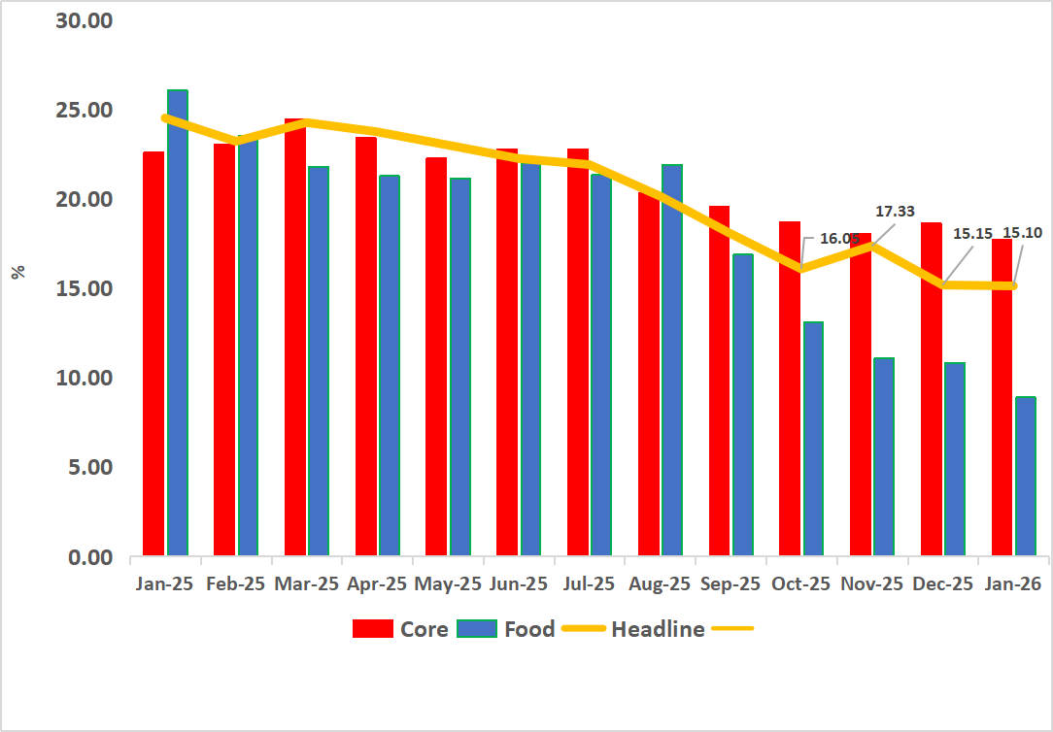
Figure 8: Year-on-Year Headline, Food and Core Inflation in Nigeria (Jan. 2025 – Jan. 2026)

Source: National Bureau of Statistics (NBS)

The Consumer Price Index (CPI) also showed a moderation in price movements during the period. On a month-on-month basis, the general price level contracted by 2.88 per cent in January 2026, compared with an increase of 0.54 per cent in December 2025, indicating that the average price of goods and services declined relative to the preceding month. This development suggests a temporary easing in short-term price pressures at the start of the year, partly reflecting improved supply conditions and adjustments following the seasonal demand typically associated with the year-end period.
Food inflation recorded the most pronounced moderation, providing significant relief in household consumption costs. On a year-on-year basis, food inflation declined sharply to 8.89 per cent in January 2026, compared with 29.63 per cent recorded in January 2025. On a month-on-month basis, food prices fell by 6.02 per cent, compared with a decline of 0.36 per cent in December, reflecting notable reductions in the prices of key food staples including grains, legumes, vegetable oils, meat, and tubers. The moderation in food prices largely reflects improved domestic supply conditions and easing seasonal pressures in agricultural markets.
Core inflation, which excludes volatile agricultural produce and energy components, also exhibited signs of easing. On a year-on-year basis, core inflation declined to 17.72 per cent in January 2026, compared with 25.27 per cent recorded in January 2025, indicating a moderation in underlying price pressures. Similarly, on a month-on-month basis, core inflation declined by 1.69 per cent, compared with an increase of 0.58 per cent in December 2025, suggesting slower price increases across non-food consumer items.

Fiscal Operations Update
Nigeria’s total public debt increased moderately to ₦153.3 trillion as of September 2025, according to the latest data released by the Debt Management Office (DMO). This represents a 0.6 per cent quarter-on-quarter (QoQ) increase and a 7.7 per cent rise on a year-on-year (YoY) basis. Although the overall debt stock continued to expand during the period, the pace of growth has slowed relative to earlier quarters. This moderation was largely supported by improved stability in the foreign exchange market, which helped reduce valuation pressures on the external component of the debt portfolio. This marks a shift from the period following the exchange rate liberalisation in June 2023, when significant depreciation of the naira substantially increased the domestic currency value of external obligations and contributed to a sharp expansion in the total public debt stock.

Figure 9: Nigeria’s Debt Profile (2023 - 2025)
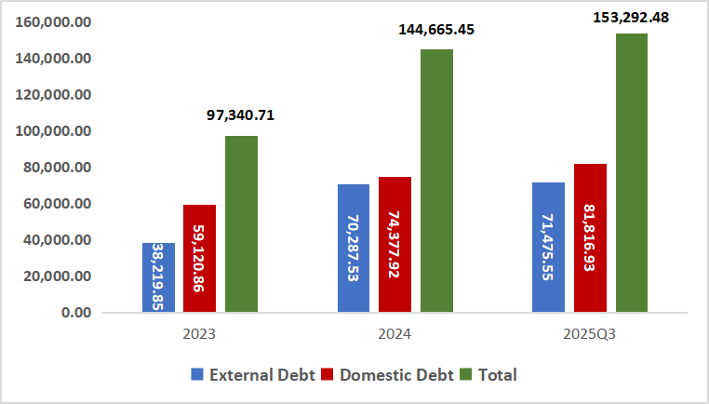

Source: Debt Management Office (DMO)

External debt obligations increased slightly in dollar terms, rising to US$48.5 billion in Q3 2025, compared with US$47.0 billion in the preceding quarter. However, when expressed in domestic currency, the value of external debt declined marginally during the quarter, falling by about 1 per cent to ₦71.5 trillion. On an annual basis, the naira value of external debt remained higher, increasing by approximately 4 per cent year-on-year. The quarterly moderation in the naira equivalent of external liabilities largely reflected the relative appreciation of the naira, with the exchange rate averaging ₦1,474.85 per US dollar during the quarter, compared with ₦1,529.21 per US dollar in the previous quarter.

Domestic debt obligations, on the other hand, continued to expand. The stock of domestic debt increased by about 2 per cent quarter-on-quarter to ₦81.8 trillion, while the year-on-year increase was more pronounced at approximately 19 per cent, reflecting continued reliance on domestic borrowing to finance fiscal operations. In terms of overall composition, domestic debt accounted for 53.4 per cent of total public debt, while external debt represented 46.6 per cent. This distribution remains broadly consistent with the targets outlined in the Medium-Term Debt Management Strategy (MTDS) 2024–2027, which recommends a 55:45 ratio between domestic and external borrowing, although the current structure indicates a slight deviation from the benchmark.
Relative to the size of the economy, Nigeria’s debt position remains moderate. When benchmarked against nominal output, the total public debt stock translates to an estimated debt-to-GDP ratio of about 36 per cent for 2025, which remains comfortably below the DMO’s self-imposed ceiling of 60 per cent. Nonetheless, the overall debt profile is expected to remain on an upward trajectory in the near term, largely reflecting the sizeable fiscal deficits projected in the medium-term fiscal framework. The 2026 fiscal deficit is estimated at ₦25.3 trillion, representing a substantial increase compared with the ₦13.5 trillion deficit projected for 2025.
Going forward, the pace of debt accumulation will depend significantly on fiscal financing needs and macroeconomic conditions. Continued stability in the exchange rate, alongside a potential decline in domestic borrowing costs, could help moderate the growth of the debt stock. However, maintaining debt sustainability will require sustained fiscal consolidation efforts, improved revenue mobilisation, and prudent debt management practices to ensure that rising borrowing requirements do not exert undue pressure on public finances.

Conclusion
The global economic outlook for 2026 is characterised by cautious optimism tempered by significant underlying risks. While global output is expected to expand at a moderate but steady pace, rising trade barriers, renewed geopolitical frictions, and shifts in investor sentiment continue to pose material downside risks. The intensification of protectionist policies—particularly through U.S. tariff measures—has deepened trade fragmentation and prolonged the reconfiguration of global supply chains. At the same time, persistent geopolitical uncertainty continues to generate volatility in energy and commodity markets and weighs on business confidence. Elevated levels of public and private debt further limit fiscal flexibility, while central banks remain constrained by the need to maintain inflation credibility without excessively restraining economic activity.
Within this challenging global environment, Nigeria has shown signs of improving macroeconomic resilience. A combination of previous tight monetary policy enhanced fiscal discipline, and selective structural reforms has contributed to greater macroeconomic stability, stronger investor confidence, and a more robust external‑reserve position. However, these gains remain vulnerable. The outlook is particularly sensitive to developments in global oil markets, where a renewed price downturn, potentially driven by expanding U.S. shale production, could place renewed strain on fiscal and external balances. Domestic constraints also persist. Infrastructure deficits, security challenges, and entrenched supply‑side rigidities continue to weigh on productivity and, if not addressed, could amplify fiscal and growth pressures over time.
Sustaining progress will require a coherent and coordinated policy strategy that strengthens macroeconomic fundamentals while accelerating structural transformation. Policy priorities must focus on deepening fiscal reforms, safeguarding monetary stability, unlocking investment in critical infrastructure, and addressing long‑standing bottlenecks that limit productivity and private‑sector expansion. By doing so, Nigeria can reinforce its resilience and better position itself to navigate an increasingly volatile global environment.

Country in Focus –Republic of Benin
Figure 10: Economic Parameters for Republic of Benin
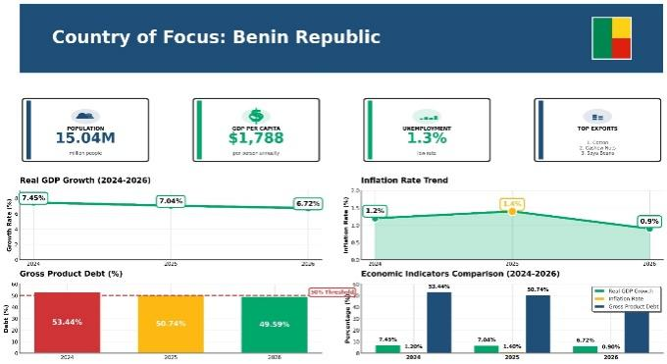
Source: CAPE Economic Research and Consulting, 2026

